CORONAVIRUS (COVID-19)
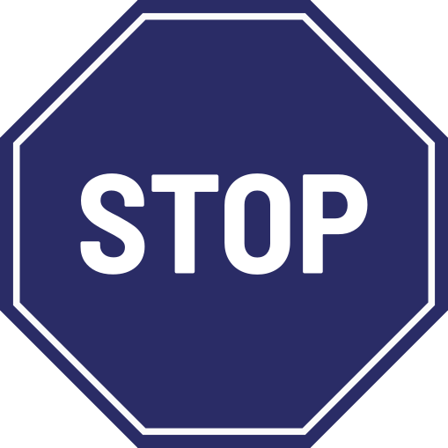

If you are displaying any symptoms of Coronavirus, please DO NOT enter our
premises and follow the
Government Stay at Home Guidance

For your safety, we are following the
2m social distancing guidance and we
may restrict the number of people entering
our premises at any one time

