CORONAVIRUS (COVID-19)
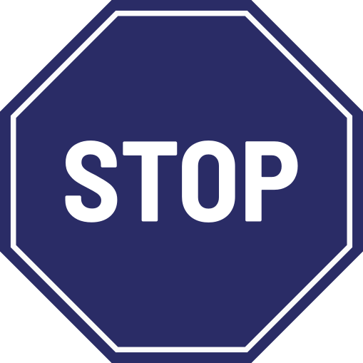

If you are displaying any symptoms of Coronavirus, please DO NOT enter our
premises and follow the
Government Stay at Home Guidance

For your safety, we are following the
1+ metre social distancing guidance and we
may restrict the number of people entering
our premises at any one time

